Week 7 Recap

Lecture 1

Components of soil and soil water: cation: and ion that carries a positive charge anion: and ion that carries a negative charge. Ion exchange is the process in which ions in solution exchange with ions on minerals and OM. We can measure cation exchange capacity (CEC): the total amount of positive charges that a particular material or soil can adsorb at a given PH. The two main controls on ion exchange are relative concentration of ion in soil solution and the strength of adsorption. The strength of adsorption is related to ionic radius and charge: smaller the radius and greater the charge the greater the force of attraction.

Don’t forget about the lyotropic series

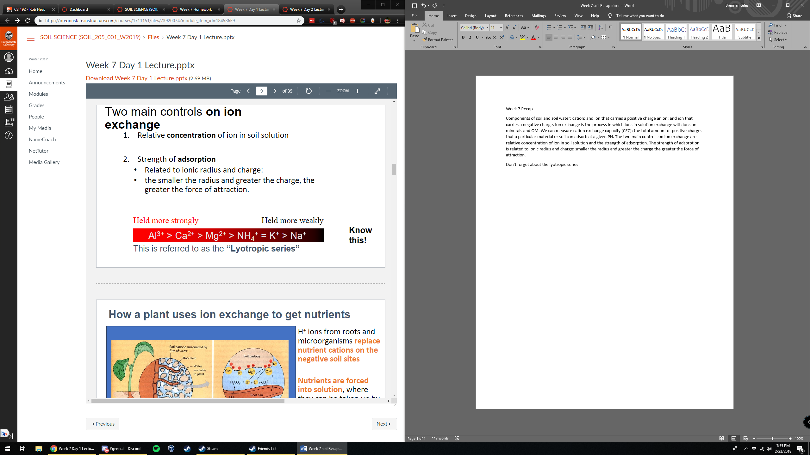

How plants get nutrients: H+ ions from roots and microorganisms replace nutrient cations on the negative soil sites. Nutrients are forced into solution where they can be taken up by roots. The interchange between a cation in solution and one on a colloid must be charge balanced.

3 factors affecting the availability of nutrients

1. Cation saturation: if high nutrient is readily available
2. Influence of other cations: if other ions are held more strongly, weakly held ion is more readily available
3. Effect of colloid type: some clays give up ions more easily than others

Lecture 2

Ph affects CEC and fertility, with a very small range allowing certain types of plants to grow. Buffering capacity = resistance of soil to changing ph.